Student’s Workbook

For
Applications Boards

12 BIT ADC & DAC
(Model – AD-DA III)

110101

Revision History

Ver. No. | Date | Affected Chapter / Page | Type of change
V 1.0 | 01/01/2011 | ----- | New release

List of Figures

Sr. no. | Fig loc^{n} no. | Description
1 | Fig1.1 | Built in power supply
2 | Fig1.2 | 12 bit ADC Dual slope (using IC 7109
3 | Fig1.3 | 12 Bit ADC SAR using IC 574
4 | Fig1.4 | 12 bit parallel DAC 1220
5 | Fig 1.5 | Sample / hold & buffer
6 | Fig 1.6 | SPI ADC & DAC
7 | Fig 1.7 | LM35- Temperature Sensor (0-5V)
8 | Fig 1.8 | Connections Details showing interface between Kit and Low cost accessory
9 | Fig 1.9 | PCB View for 12 bit AD DA
10 | Fig 1.10 | Flow chart for 12 bit ADC(7109)
11 | Fig 1.11 | Flow chart for 12 bit Parallel DAC

II. List of Tables

Sr no. | loc^{n} no. | Description
1 | Table 1.1 | Resources & shared control pins
2 | Table 1.2 | Control Pins for 4053
3 | Table 1.3 | 26 Pin FRC Connector (J3)
4 | Table 1.4 | 4 Pin Male Reliamate (J2)
5 | Table 1.5 | Shared control pins
6 | Table 1.6 | User modifiable control links:-
7 | Table 1.7 | List of BS5 sockets

AD-DA III

Unit Objective:
At the completion of this unit you will be able to understand which 12 bit converters are & how to work with them?
Note: Following unit describes all the converters implemented on this panel but not all of them can be assembled together since they share many common control pins. Typically only a pair of ADC, DAC will be supplies at a time as per order.

Discussion on Fundamentals:
Microprocessor is a logic control device; it processes digital signals that are binary and discontinuous. On the other hand, the real word physical quantities are such as temperature and pressure, are continuous. These are represented by equivalent electrical quantities called analog signals. Even though analog signals may represent real physical parameters with accuracy, it is difficult to process or store the analog signal for later use without introducing considerable error. Therefore in microprocessor based industrial applications it is necessary to convert this analog signals to digital signals.

Table 1.1 Resources & shared control pins
Sr. no. | Resource name/specs. | Interface Signals | Control signals |  |  | Voltage range | Can’t share with
1 | ADC 7109 dual slope, 1sec per sample | PB0-PB7 lower 8 bytes, pb0-pb3 upper 4 bytes, pb6-or & pb7-pol | LBEN-PC4  HBEN-/PC4  PC7-R/H  PC0-ADC status |  |  | +/- 4V | ADC574  ADC 3301
2 | ADC AD574 12 bit SAR usec/samples | PB0-PB7 lower 8 bit, PB0-PB7-upper 4 byte | A0-PC4  R/C-/PC7  PC0-ADC status |  |  | +/- 5V | ADC7109  ADC 3301
3 | DAC 1220 parallel 12 bit | PA0-PA7-upper  PC0-PC3-lower | Though PC0 is shared, being LSB it can be pulled down to gnd & used |  |  | +/- 4V | DAC4921
4 | S / H , buffer | - | PC6 | 1 | sample |  | DAC4921
 |  |  |  | 0 | hold |  | DAC4921
5 | I/P external or internal from pot | - | SPDT |  | up | +/- 5V | -
 |  |  |  |  | dn | 0-5Vor  +/- 5V | -
6 | LM35-Temp Sensor | - | - |  |  | 0-5V | -
7 | SPI ADC 3301-12 bit | - | PC4-SCK  PC2-SDI  PC7-ICS |  |  | 0-5V | ADC7109  ADC574
8 | SPI DAC 4921-12 bit | - | PC4-SCK  PC2-SDO  PC6-ICS |  |  | 0-5V | ADC7109  ADC574  DAC1220  S/H

Fig 1.1 Built in power supply:-
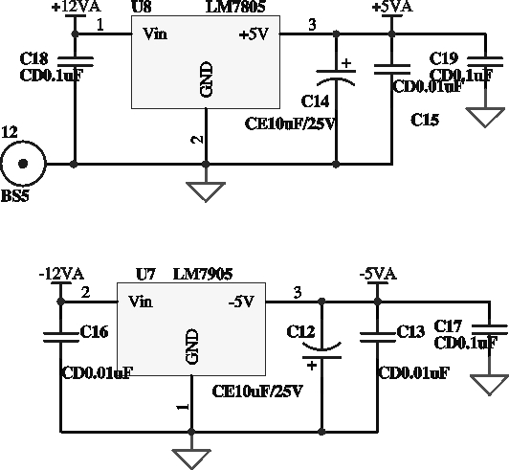

Fig 1.2 12 bit ADC Dual slope (using IC 7109):-
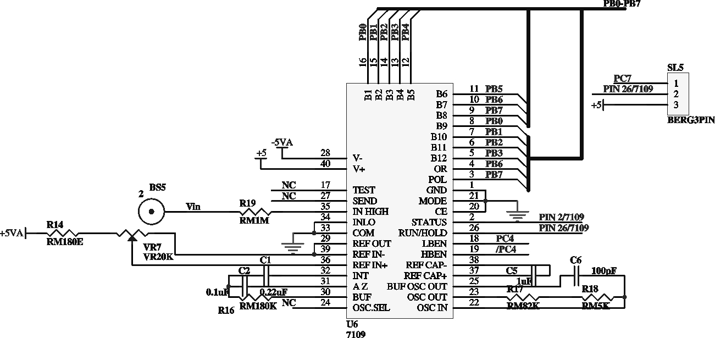

Analog to digital interface is implemented using 12 bit dual slope integrating type intersil IC 7109, connector J4 provides the requisite analog power supply +12V & J3 provides the Microprocessor interface, the analog input to the ADC comes through J1 & IT can be connected to onboard pot by keeping sw1 in down position.(i.e. port B of 4051 is selected) connect socket 2 to socket 4 which preset provides the required +4V variable voltage source which is continuously converted into digital Hex number & displayed at the output console.
The o/p data 12 bits, polarity, over range may be directly accessed under control of two byte enable inputs & a chip select input for a simple parallel bus interface.

ADC (IC 574):
The AD574A is a complete 12-bit successive-approximation analog-to-digital converter with 3-state output buffer circuitry for direct interface to an 8- or 16-bit microprocessor bus. A high precision voltage reference and clock are included on-chip, and the circuit guarantees full-rated performance without external circuitry or clock signals. Connect socket1 to socket 4.
Fig 1.3 12 Bit ADC SAR using IC 574:-
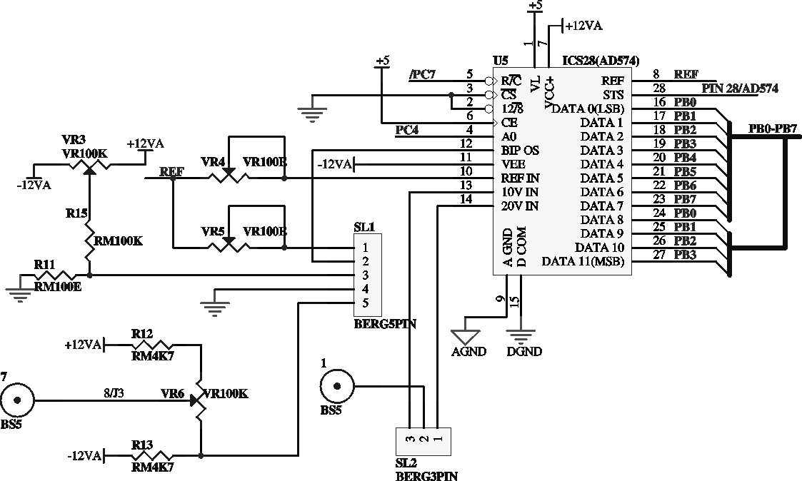

DAC (1220):
I/P to DAC is given through microprocessor, which is 12 bit data in binary form. O/P of DAC 1220 is current, which is converted into proportional voltage using I to V converter (IC TL082 as I to V converter). Hence you can perform experiment & observe the O/P of DAC for 4096 different 12 bit digital signals (from 0000000 to 111111111111) using Microprocessor.

Fig 1.4 12 bit parallel DAC 1220:-
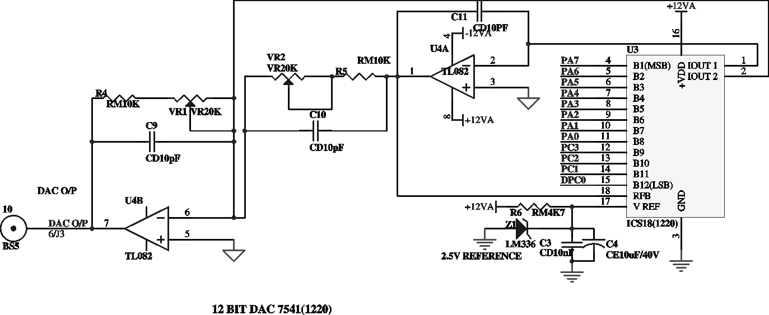

Sample / hold & buffer, External input or input from pot:-
Using 4053 i.e. by controlling PC5, PC6 & switch SPDT (port A, B & C of 4053) input selection is done.

Table 1.2 Control Pins for 4053
Port | LPC | status |  | Link
C | PC5 | High | Either ADC status | SL3
C | PC5 | low | Shorts DPC0 to PC0 | SL3
B | SPDT  switch | Up | External input | -
B | SPDT  switch | down | Input from pot | SL4
A | PC6 | High | Sample | Sw1 up short BS5 4 to 5.
A | PC6 | low | Hold | Sw1 up short BS5 4 to 5.
Keep sw1 in down position. Internal input to ADC is given by varying pot. Input can be varied from 5V to +5V or 0V to +5V depending on which ADC is used by proper link setting of SL4. It is available on socket no. 4.
Keep sw1 in up position. External input can be applied at socket 5.
Fig 1.5 Sample / hold & buffer:-

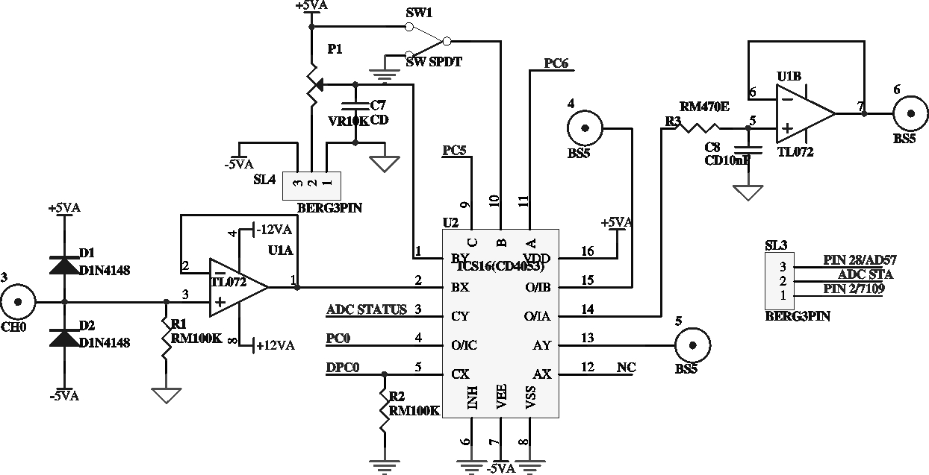

Fig 1.6 SPI ADC & DAC:-
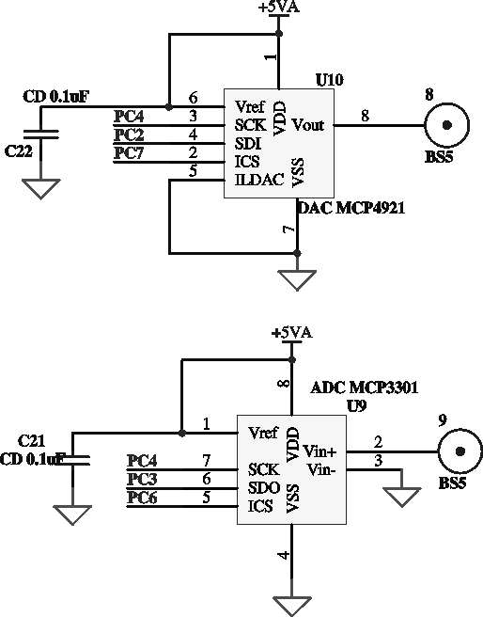

Fig 1.7 LM35- Temperature Sensor (0-5V):-
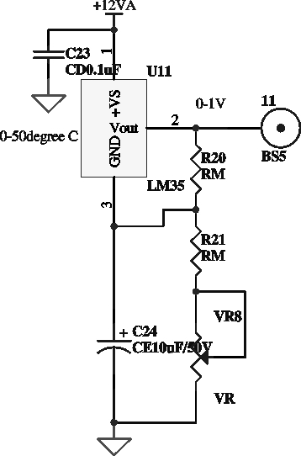

Table 1.3 26 Pin FRC Connector (J1)
Pin No. | Description | Pin No. | Description | Pin No. | Description
1 | PC₄ | 10 | PB₅ | 19 | PA₂
2 | PC₅ | 11 | PB₂ | 20 | PA₃
3 | PC₂ | 12 | PB₃ | 21 | PA₀
4 | PC₃ | 13 | PB₀ | 22 | PA₁
5 | PC₀ | 14 | PB₁ | 23 | PC ₆
6 | PC₁ | 15 | PA₆ | 24 | PC ₇
7 | PB₆ | 16 | PA₇ | 25 | 0VD
8 | PB₇ | 17 | PA₄ | 26 | +5VD
9 | PB₄ | 18 | PA₅

anshuman
Low cost
accessory
Kit
26 pin FRC
cable
Side View
Elevation
26 pin female
connector
26 pin female
connector
PP
Top cover
Base
26 pin FRC
cable

Polarity
Protector
Fig 1.8 Connections Details showing interface between Kit
and Low cost accessory

Table 1.4 4 Pin Male Relimate (J2)
Pin No. | Description | Pin No. | Description
1 | +12VA | 3 | GND
2 | -12VA | 4 | +5VA

Table 1.5 Shared control pins
Port  No. | ADC  574 | ADC 7109 | DAC  1220 | ADC  3301 | DAC  4921 | 4053
PC0 | ADC STATUS |  | Upper  4 bits
PC1 |  |  | Upper  4 bits
PC2 |  |  | Upper  4 bits | SDI
PC3 |  |  | Upper  4 bits |  | SDO
PC4 | A0 | LBEN |  | SCK | SCK
/PC4 |  | HBEN
PC5 |  |  |  |  |  | Port C
PC6 |  |  |  |  | ICS | Port A
PC7 |  | R/H |  | ICS
/PC7 | R/C

Table 1.6 User modifiable control links:-
Link | For |  | Default set
SL1 | Input for 574 | Short Pin 1-2, 3-4 for 5VA to +5VA | √
SL1 | Input for 574 | Short Pin 2-3,4-5 for 0 to +10VA | -
SL2 | Input for 574 | Short Pin 3 to 2 for 10V input | √
SL2 | Input for 574 | Short Pin 1 to 2 for 20V input | -
SL3 | ADC status | Short Pin 3 to 2 | ADC 7109
SL3 | ADC status | Short Pin 1 to 2 | ADC 574
SL4 | Input from  pot | Short Pin 1 to 2 for 0V to +5V | ADC 3301
SL4 | Input from  pot | Short Pin 3 to 2 for -5V to +5V | ADC 574,ADC 7109
SL5 | ADC status of 7109 | Short Pin 3 to 2 for pin 26/7109 to PC7 | √
SL5 | ADC status of 7109 | Short pin 1 to 2 for continuous mode | -

Table 1.7 List of BS5 sockets
Tag | Function
1 | Input for AD574
2 | Input for AD574
3 | External input
4 | Input from pot or externally
5 | Input for S/H
6 | Output for S/H
7 | Input from pot
8 | SPI DAC Output
9 | SPI ADC Output
10 | DAC Output
11 | LM35 output
12 | GND

Fig 1.9 PCB View for 12 bit AD DA:-
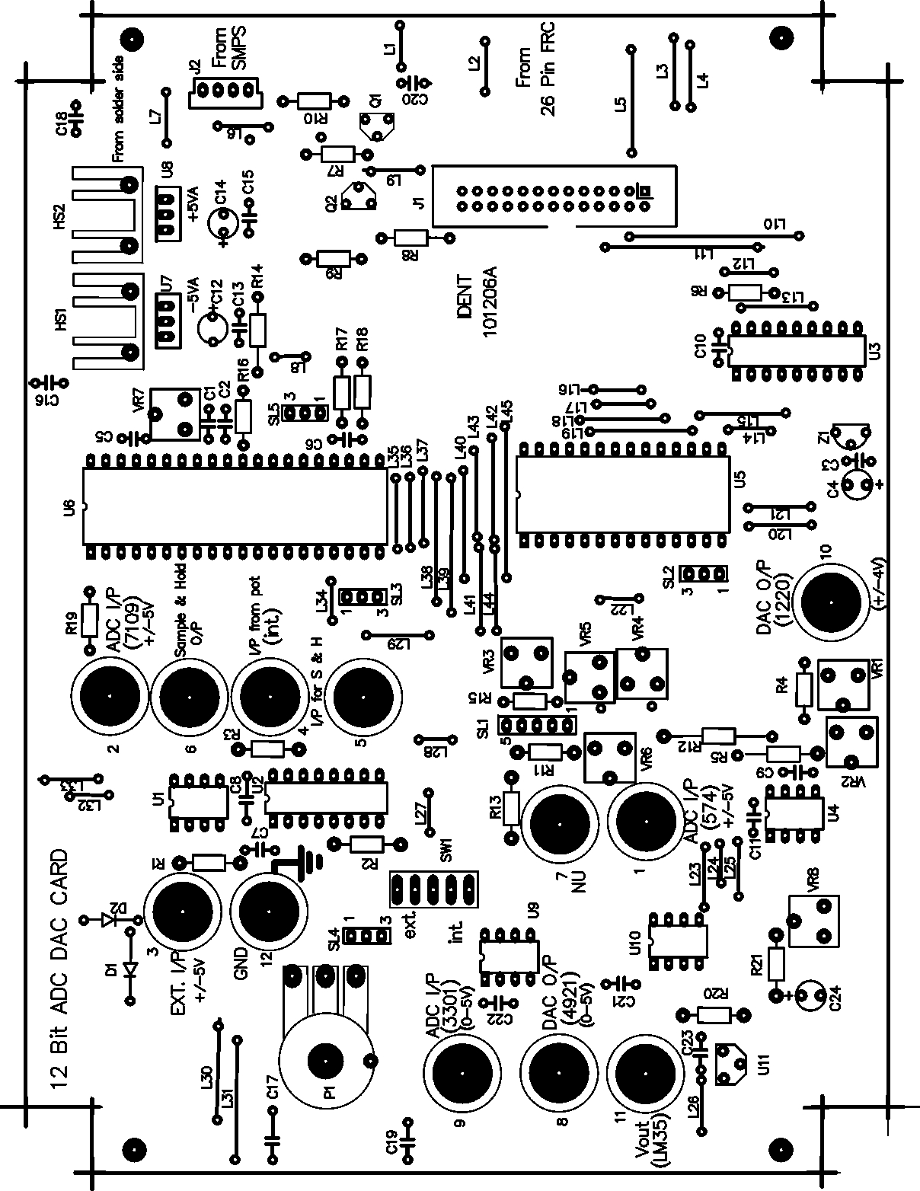

Assignment 1:-
Write a program to convert analog input into 12 bit Hex no..
Procedure:-
- Keep switch sw1 (SPDT) in down position.(internal input by varying pot is selected) input +5V.
- Connect socket 4 to socket 2.( ADC input is applied to ADC 7109)
Fig 1.10 Flow chart for 12 bit ADC(7109) :-

YES
Start
Start Conversion
Really Begun ?
Conversion Really Ended?
Read upper & lower byte,
Separate +, over range Information and display at present console
Check any key pressed
At keyboard
Return to command mode
YES
YES
Initialise PIO ports A, B, Input, upper port C as output, lower port C as input

Assignment 2:-
Write a program to convert 12 bit digital data (input) into analog input (voltage)
Observe DAC O/p +4V ramp at socket 10.
Fig 1.11 Flow chart for 12 bit Parallel DAC:-
YES
Start
Start Conversion
Is desired ramp attained
Observe ramp waveform
@ Socket no. 10
Check any key pressed
at keyboard
Return to command mode
YES
YES
Initialize PIO ports A, C as output
port B as Input
Is desired height attained?

Blank Page

